199333274/84ak4d

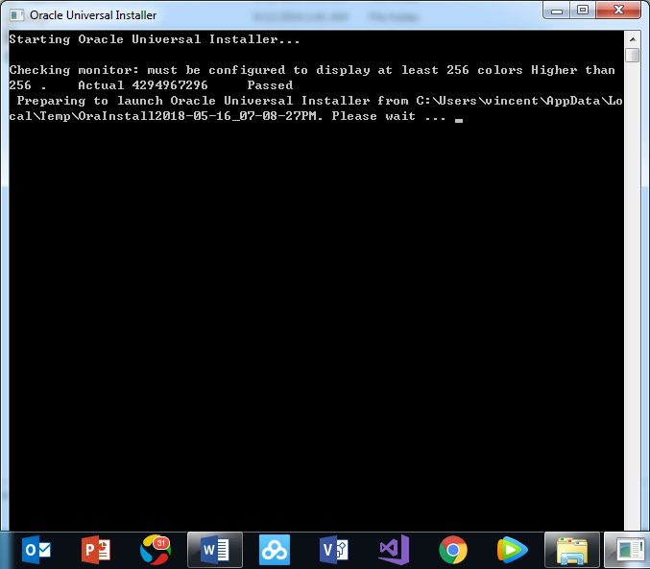



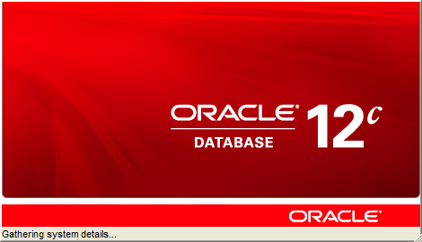

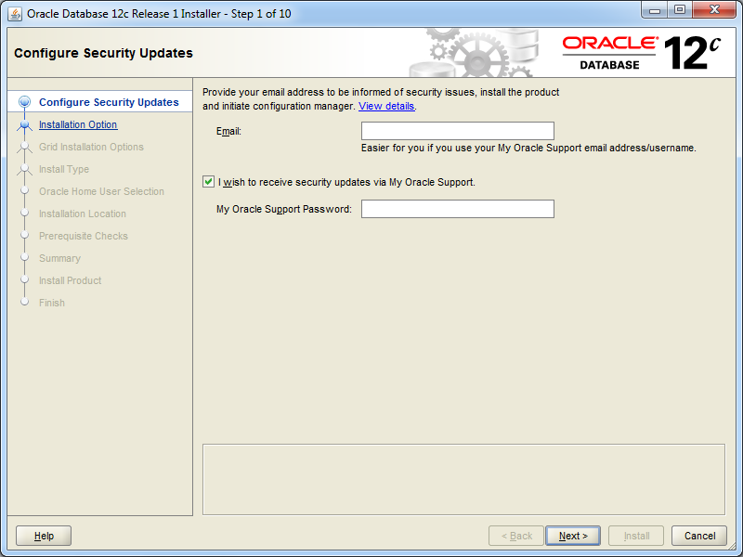

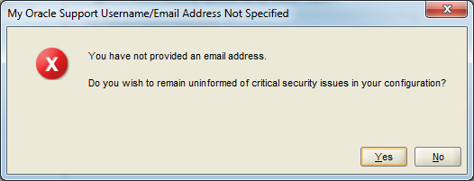

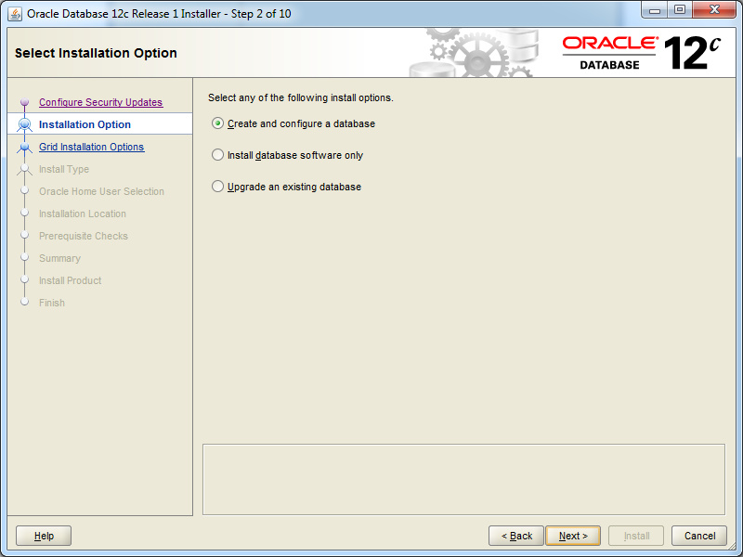

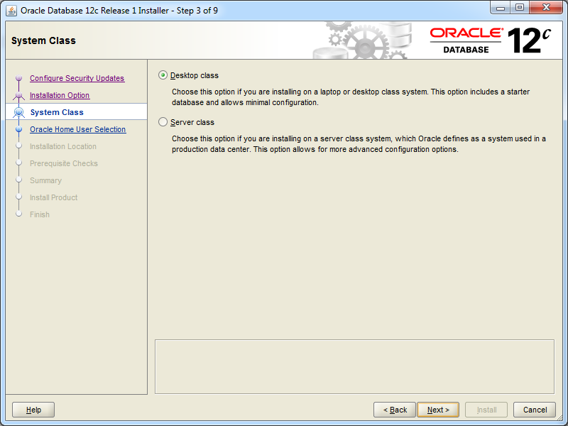

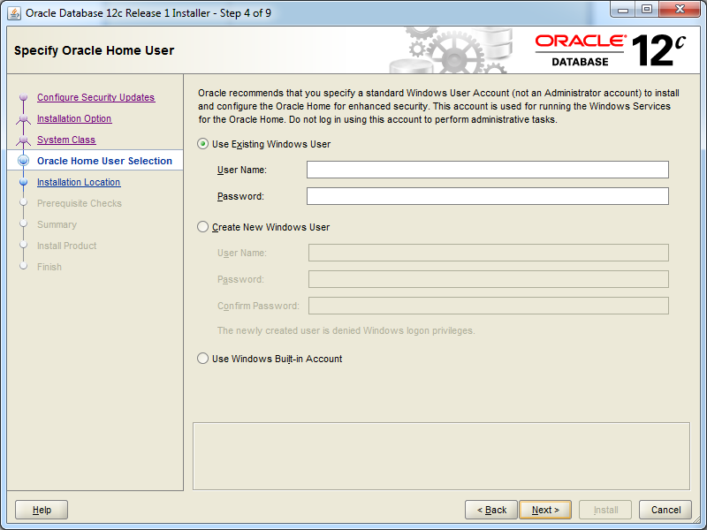

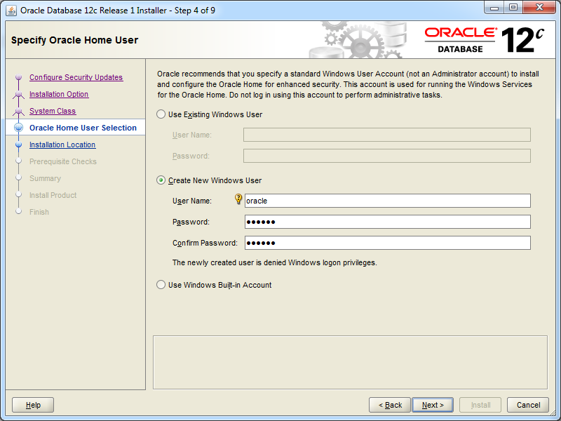

oracle/oracle

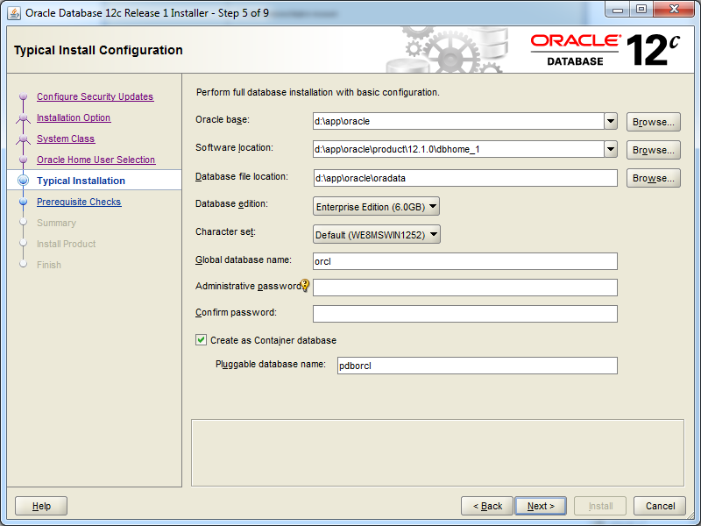

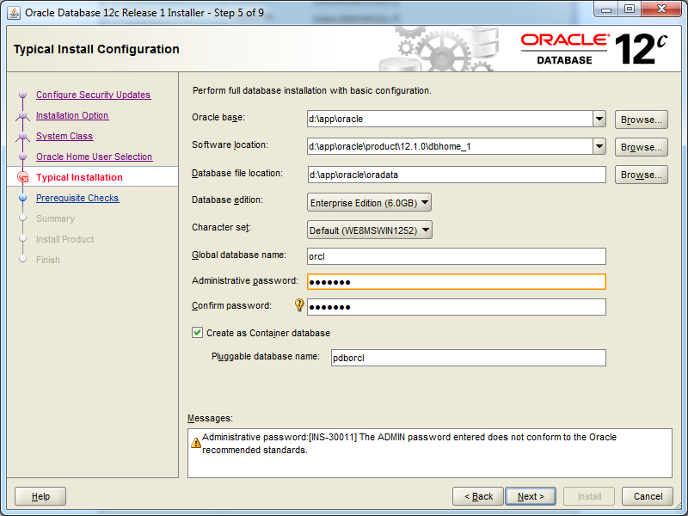

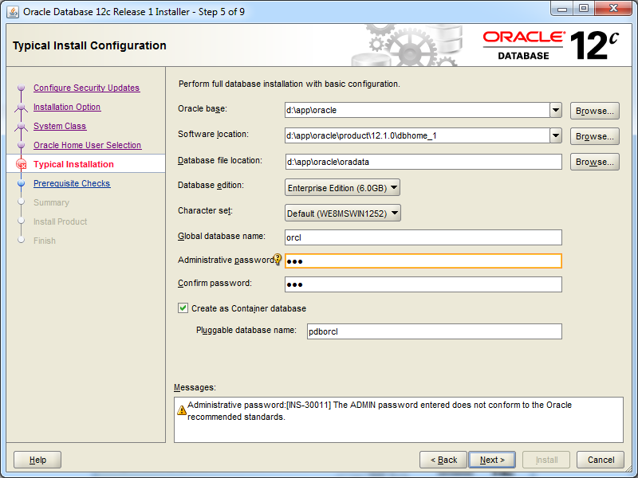

cug

* Administrative password:[INS-30011] The ADMIN password entered does not conform to the Oracle recommended standards.

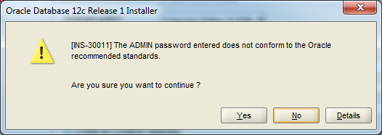

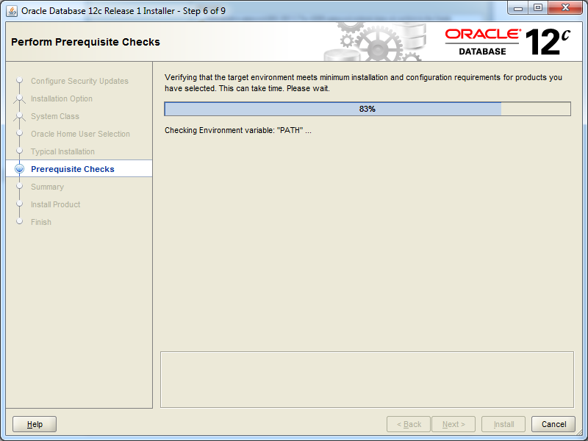

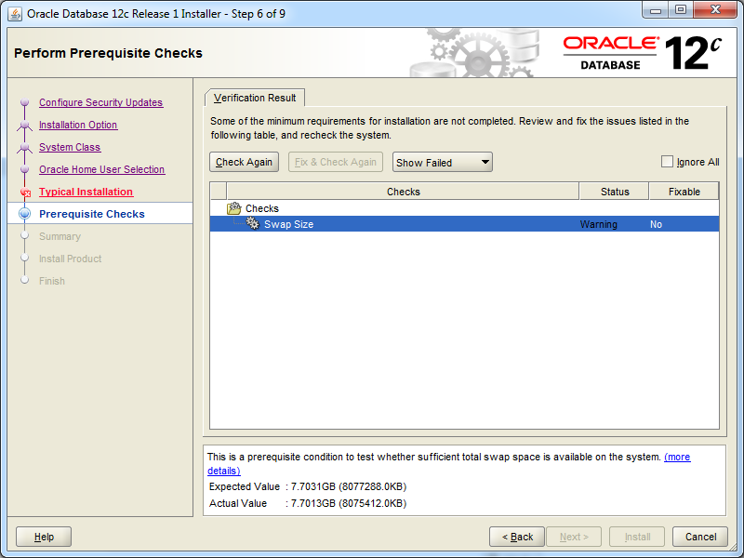

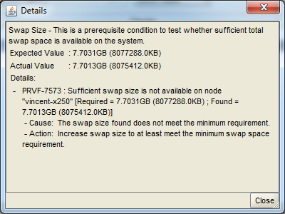

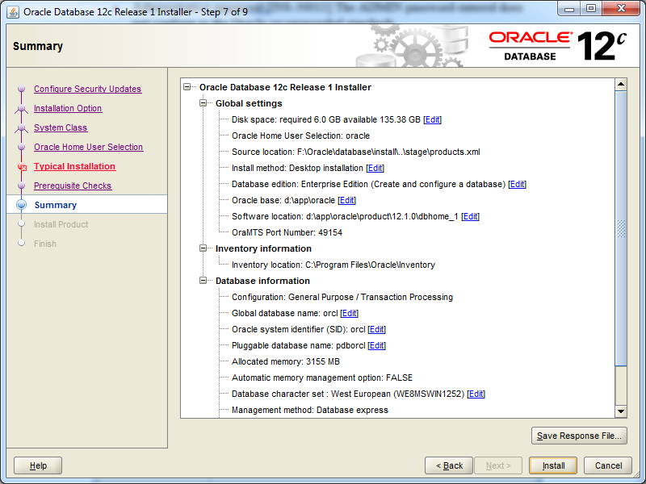

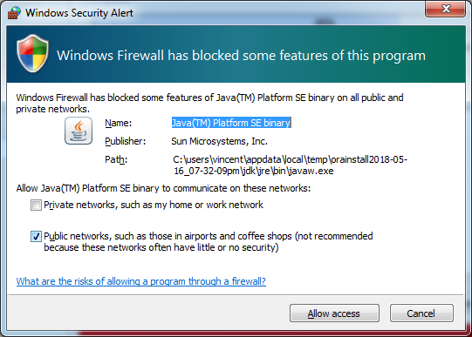

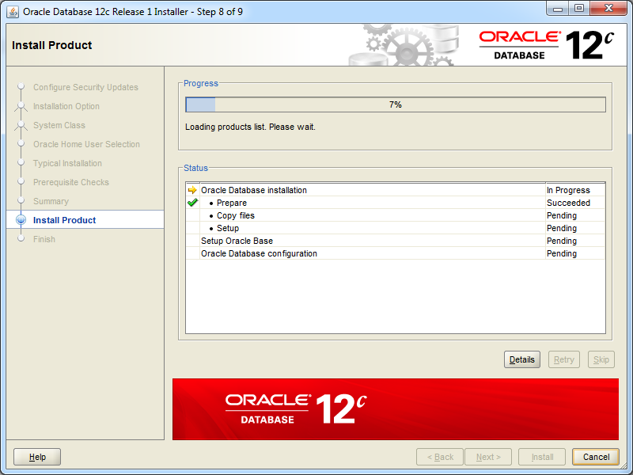

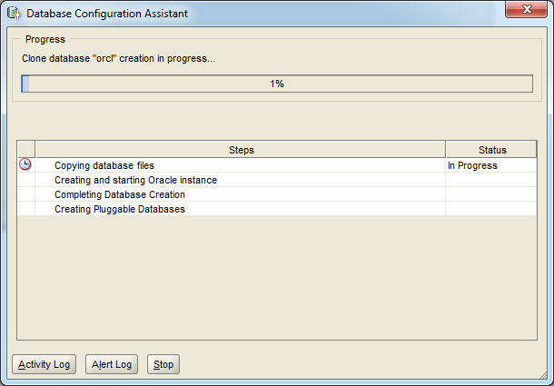

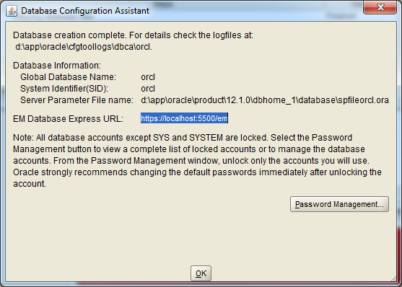

sys/cug

system/cug

mdsys/cug

spatial/spatial

mvdemo/mvdemo

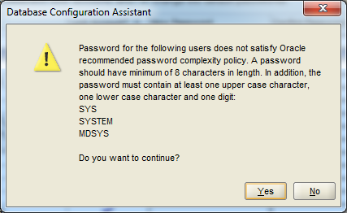

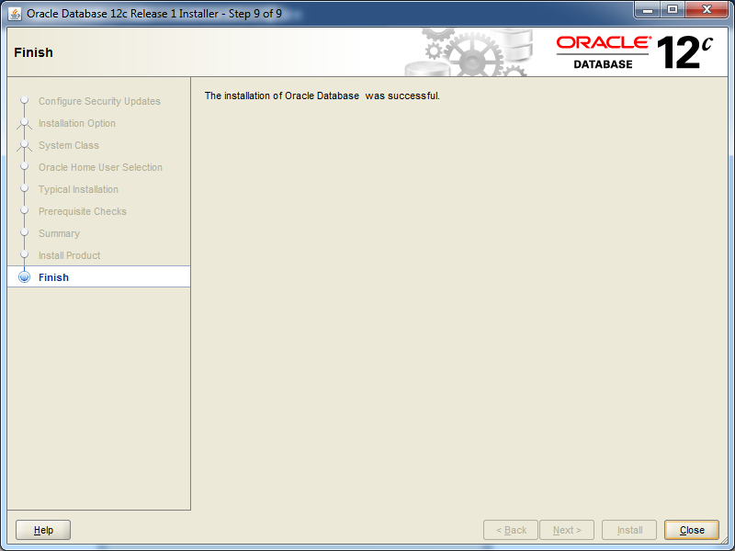

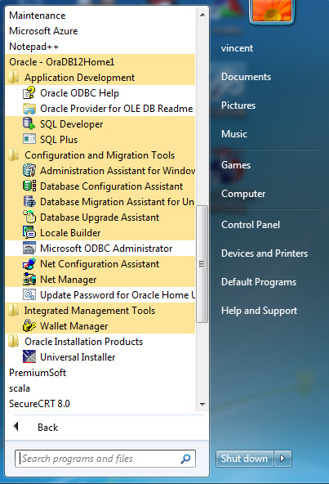

配置pdborcl可插拔数据库访问：

D:\app\oracle\product\12.1.0\dbhome_1\NETWORK\ADMIN\tnsnames.ora

PDBORCL =

(DESCRIPTION =

(ADDRESS = (PROTOCOL = TCP)(HOST = localhost)(PORT = **1521**))

(CONNECT_DATA =

(SERVER = DEDICATED)

(SERVICE_NAME =pdborcl)

)

)

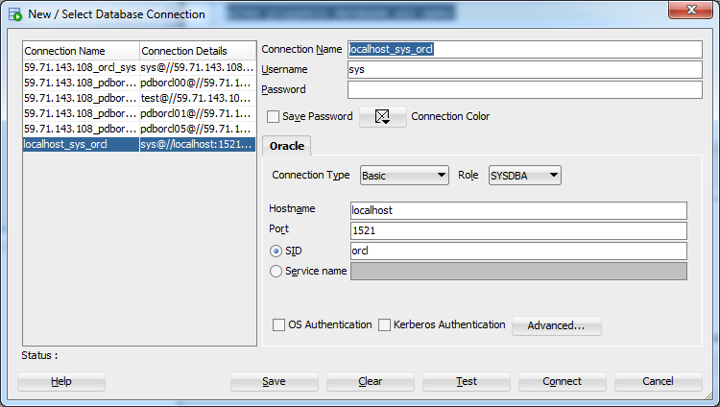

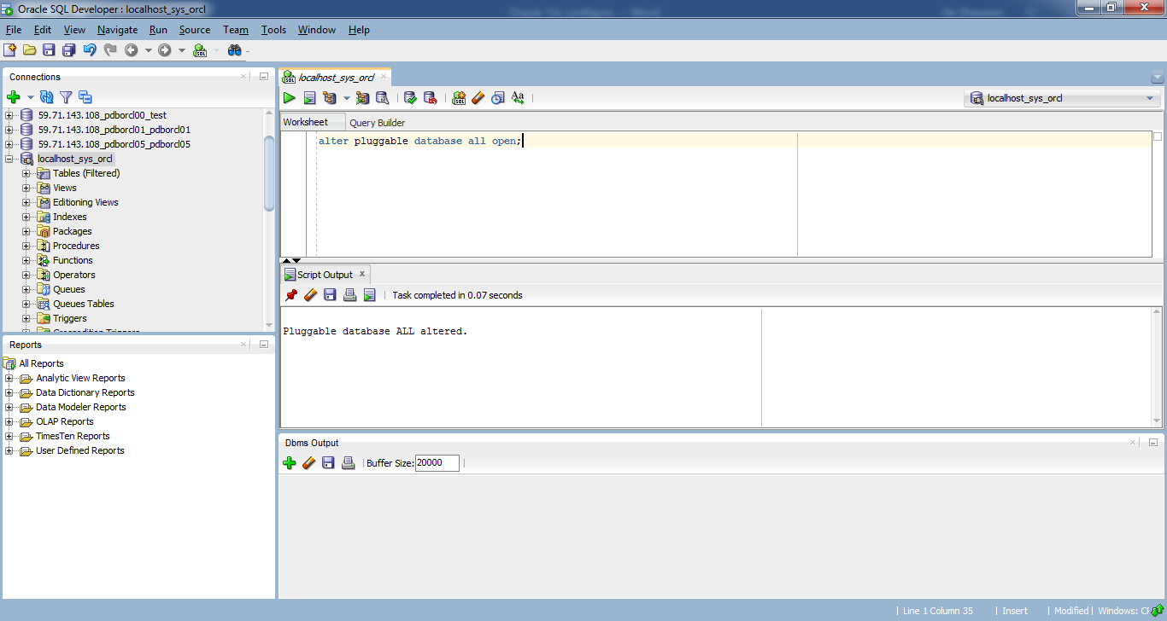

alter pluggable database all open;

Pluggable database ALL altered.

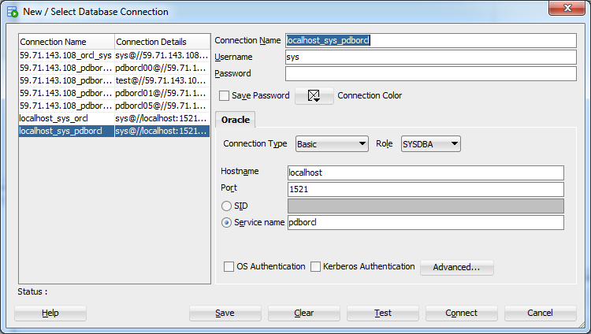

创建四个用户spatial, ovcdemo, mvdemo, ndmdemo

-- USER SQL

CREATE USER spatial IDENTIFIED BY "spatial"

DEFAULT TABLESPACE "USERS"

TEMPORARY TABLESPACE "TEMP";

-- QUOTAS

ALTER USER spatial QUOTA UNLIMITED ON USERS;

-- ROLES

GRANT "DBA" TO spatial ;

GRANT "CONNECT" TO spatial ;

GRANT "RESOURCE" TO spatial ;

-- USER SQL

CREATE USER mvdemo IDENTIFIED BY "mvdemo"

DEFAULT TABLESPACE "USERS"

TEMPORARY TABLESPACE "TEMP";

-- QUOTAS

ALTER USER mvdemo QUOTA UNLIMITED ON USERS;

-- ROLES

GRANT "DBA" TO mvdemo ;

GRANT "CONNECT" TO mvdemo ;

GRANT "RESOURCE" TO mvdemo ;

-- USER SQL

CREATE USER ndmdemo IDENTIFIED BY "ndmdemo"

DEFAULT TABLESPACE "USERS"

TEMPORARY TABLESPACE "TEMP";

-- QUOTAS

ALTER USER ndmdemo QUOTA UNLIMITED ON USERS;

-- ROLES

GRANT "DBA" TO ndmdemo ;

GRANT "CONNECT" TO ndmdemo ;

GRANT "RESOURCE" TO ndmdemo ;

-- USER SQL

CREATE USER ovcdemo IDENTIFIED BY "ovcdemo"

DEFAULT TABLESPACE "USERS"

TEMPORARY TABLESPACE "TEMP";

-- QUOTAS

ALTER USER ovcdemo QUOTA UNLIMITED ON USERS;

-- ROLES

GRANT "DBA" TO ovcdemo ;

GRANT "CONNECT" TO ovcdemo ;

GRANT "RESOURCE" TO ovcdemo ;

查看dba_directores表，select * from dba_directories;

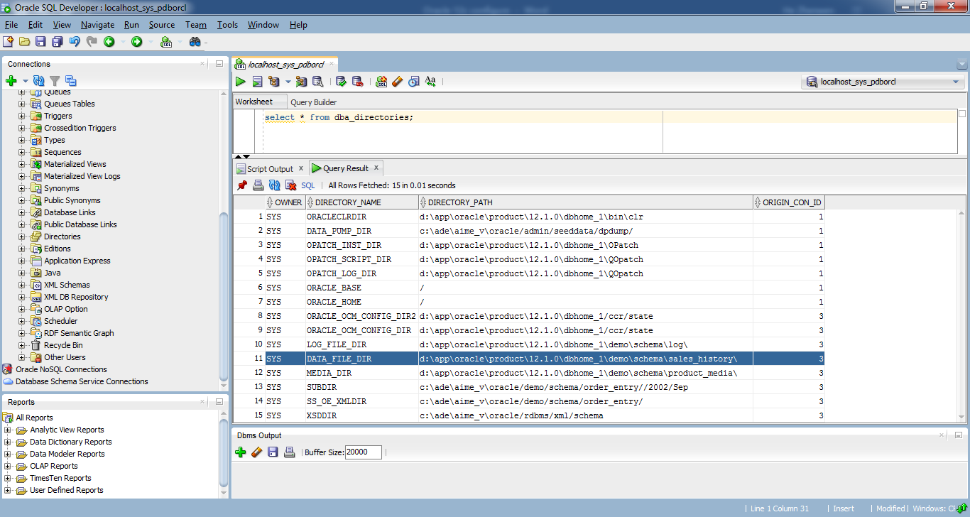

为避免需要创建新的目录，我们直接将要导入的数据放在DATA_FILE_DIR，其默认指向为：d:\app\oracle\product\12.1.0\dbhome_1\demo\schema\sales_history\

将示例文件拷贝到该目录下：

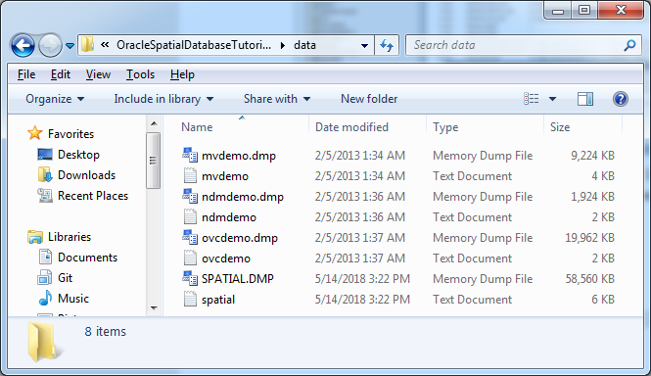

impdp spatial/spatial@pdborcl directory= DATA_FILE_DIR dumpfile= spatial.dmp logfile= spatial.log schemas=spatial

imp mvdemo/mvdemo@pdborcl file= D:\app\oracle\product\12.1.0\dbhome_1\demo\schema\sales_history\mvdemo.dmp full=yes

imp ndmdemo/ndmdemo@pdborcl file= D:\app\oracle\product\12.1.0\dbhome_1\demo\schema\sales_history\ndmdemo.dmp full=yes

imp ovcdemo/ovcdemo@pdborcl file= D:\app\oracle\product\12.1.0\dbhome_1\demo\schema\sales_history\ovcdemo.dmp full=yes

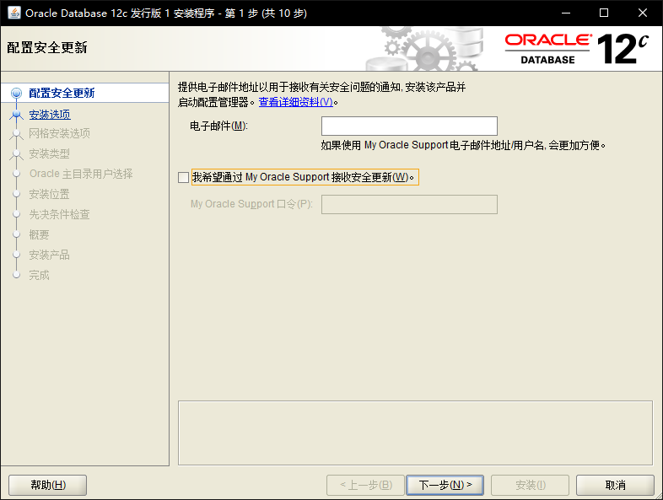

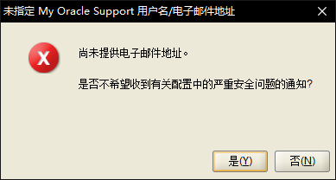

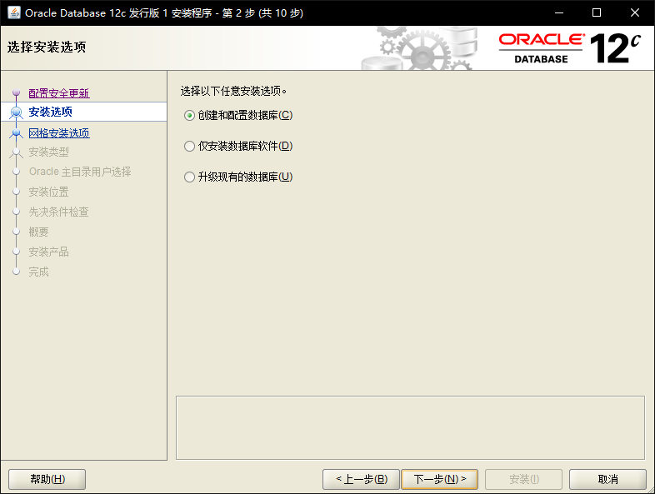

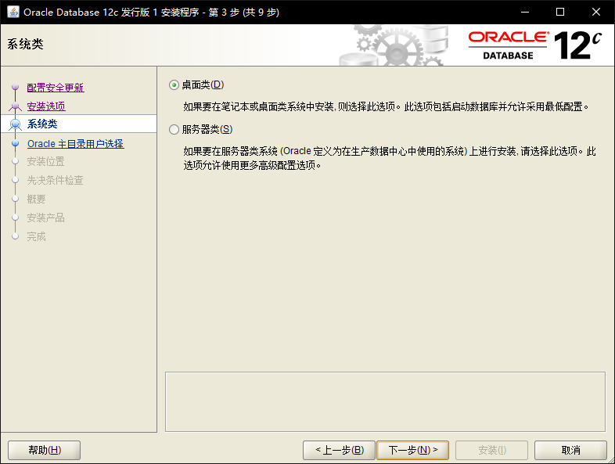



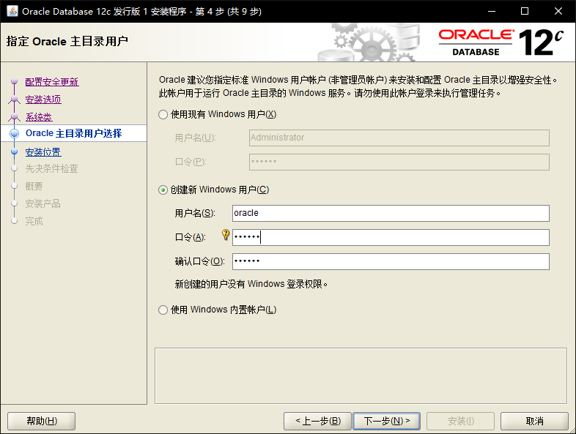

oracle/oracle

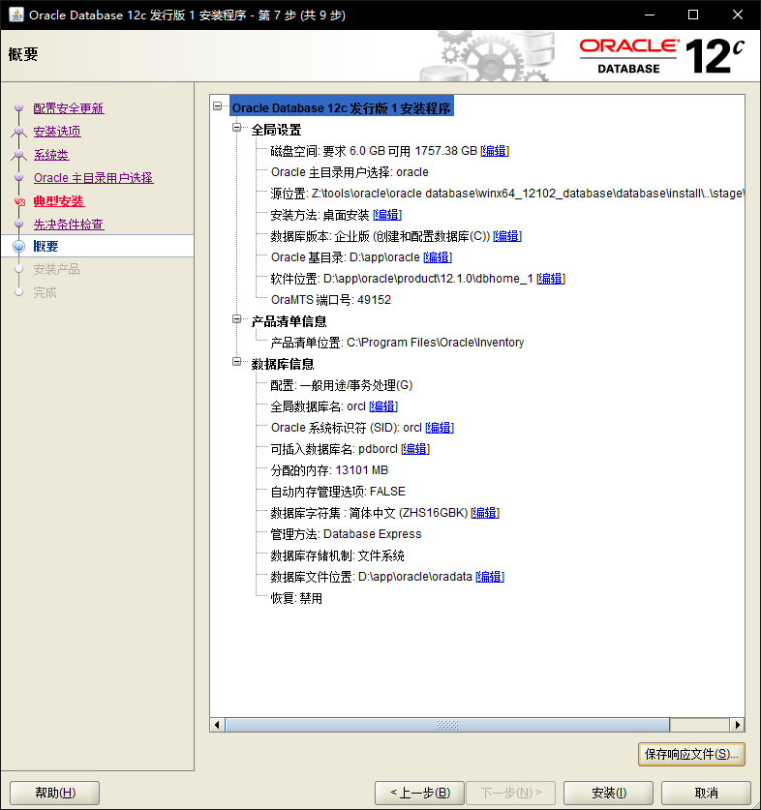

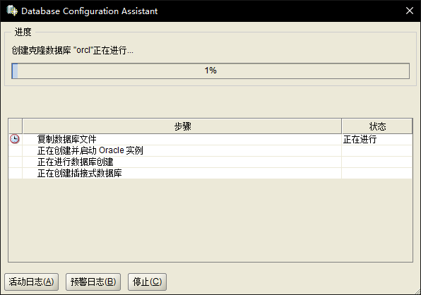

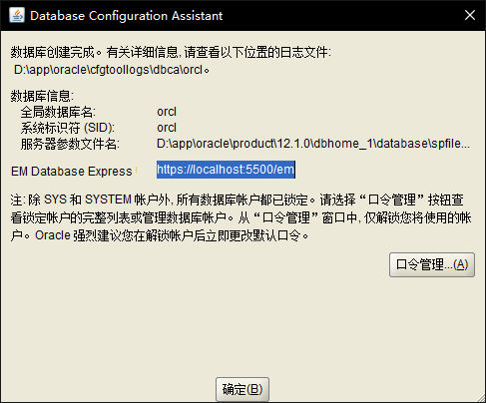

sys/cug

system/cug

mdsys/cug

spatial/spatial

mvdemo/mvdemo

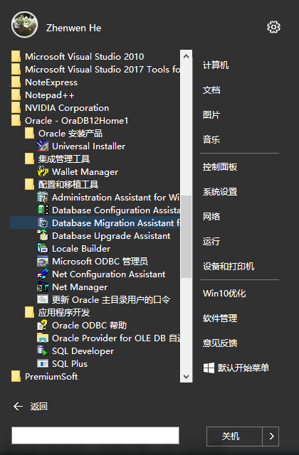

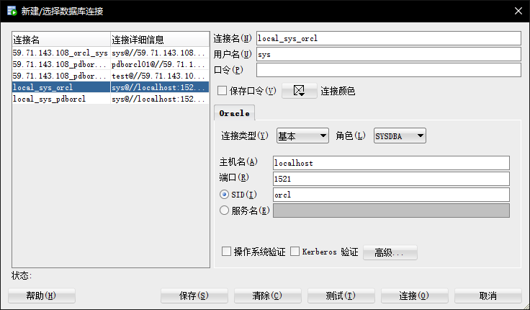

alter pluggable database all open;

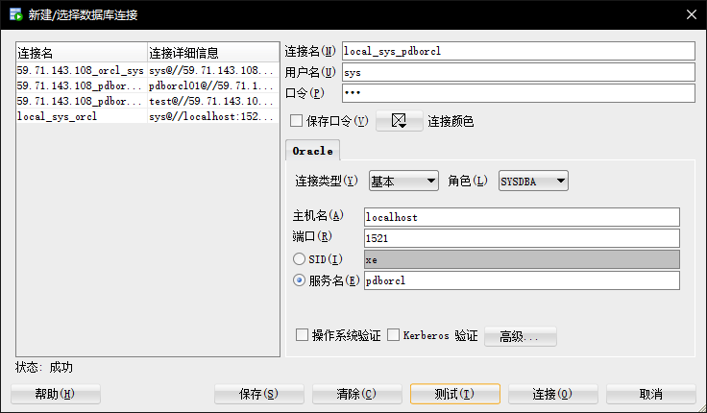

-- USER SQL

CREATE USER spatial IDENTIFIED BY "spatial"

DEFAULT TABLESPACE "USERS"

TEMPORARY TABLESPACE "TEMP";

-- QUOTAS

ALTER USER spatial QUOTA UNLIMITED ON USERS;

-- ROLES

GRANT "DBA" TO spatial ;

GRANT "CONNECT" TO spatial ;

GRANT "RESOURCE" TO spatial ;

-- SYSTEM PRIVILEGES

D:\app\oracle\product\12.1.0\dbhome_1\NETWORK\ADMIN\tnsnames.ora

PDBORCL =

(DESCRIPTION =

(ADDRESS = (PROTOCOL = TCP)(HOST = localhost)(PORT = **1521**))

(CONNECT_DATA =

(SERVER = DEDICATED)

(SERVICE_NAME =pdborcl)

)

)

imp spatial/spatial@pdborcl file=f:/examples/data/zip.dmp full=y

imp spatial/spatial@pdborcl file=f:/examples/data/styles.dmp full=y

imp spatial/spatial@pdborcl file=f:/examples/data/routing.dmp full=y

imp spatial/spatial@pdborcl file=f:/examples/data/net.dmp full=y

imp spatial/spatial@pdborcl file=f:/examples/data/map_large.dmp full=y

imp spatial/spatial@pdborcl file=f:/examples/data/map_detailed.dmp full=y

imp spatial/spatial@pdborcl file=f:/examples/data/gc.dmp full=y

imp spatial/spatial@pdborcl file=f:/examples/data/citybldgs.dmp full=y

imp spatial/spatial@pdborcl file=f:/examples/data/app_with_loc.dmp full=y

导出本书对应的数据spatial.dmp文件

expdp spatial/spatial@pdborcl directory=DATA_FILE_DIR dumpfile=spatial.dmp logfile=spatial.log schemas=spatial

后期要用该数据，导入的命令行为：

impdp spatial/spatial@pdborcl directory= DATA_FILE_DIR dumpfile= spatial.dmp logfile= spatial.log schemas=spatial

